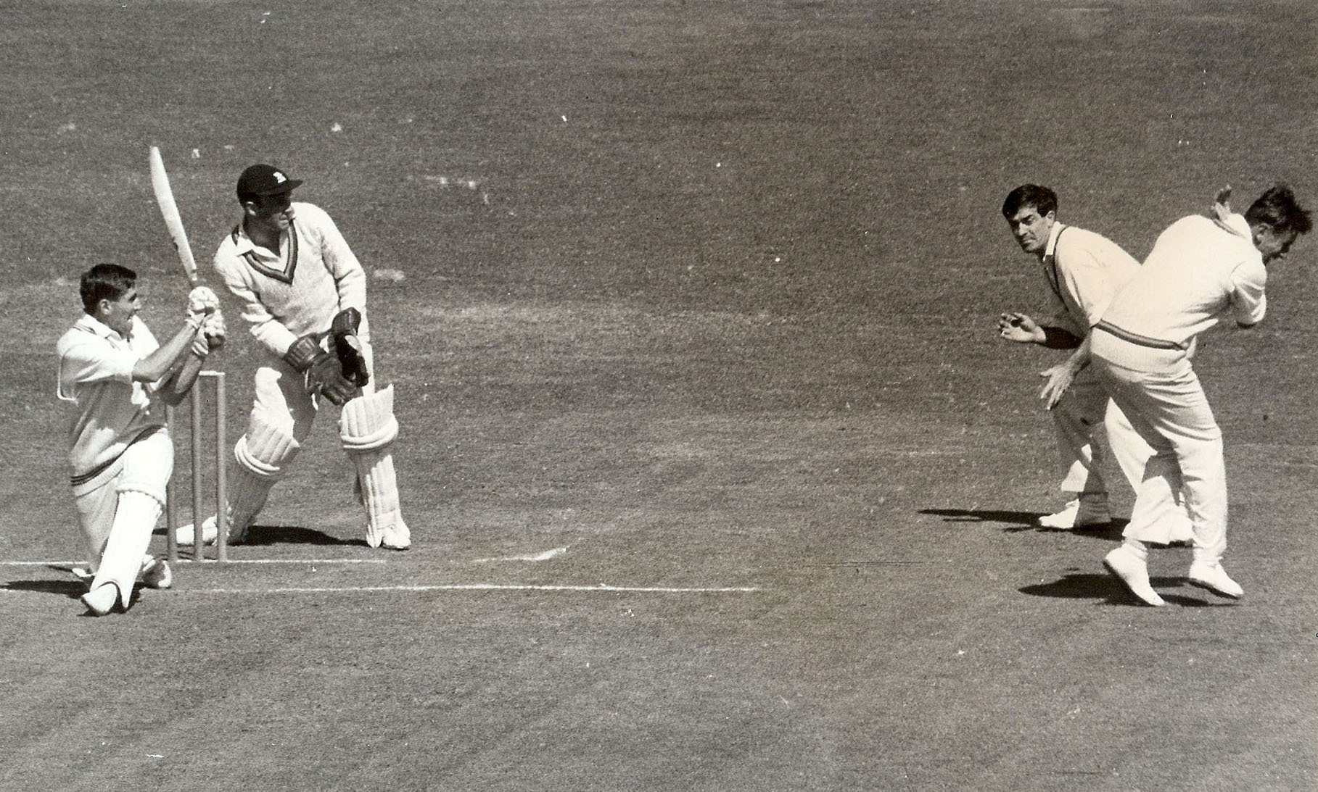

**GT Dowling swepts. New Zealand v MCC 15 March 1963. Lancaster Park AC Smith wicket keeper.**

**ER Dexter ducking**